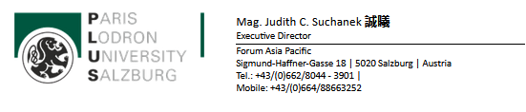
Honorable Presidents,
Honorable Professors, Honorable Directors,
Dear Colleagues, Dear Students,
Warm Greetings from Salzburg University and the Forum Asia Pacific!
We hereby would like to officially announce our new FOR APAC International Summer School 2023!
After two years, we are delighted to bring back the Summer School in presence, with a rich program that spans over 6 countries!
It is now for the first time possible to choose between two programs: 4 weeks (6 countries) or 2 weeks (only in Austria).
Please find the announcement brochure, the official programs and the poster in the attachments!
We sincerely hope that these programs will meet your and your students’ interest.
Please kindly forward this information to students and colleagues who might be interested!
The deadline for the online application and the nomination is the 1st of April 2023.
We are very much looking forward to hearing from you and your students and to cooperating with you in the frame of our FOR APAC International Summer School 2023!

Yours sincerely,
Judith Suchanek
Program Coordinator
In the name of the FOR APAC Team
Δείτε και τα συνημμένα αρχεία:
Announcement Brochure FOR APAC International Summer School 2023.pdf
Poster FOR APAC International Summer School 2023.pdf
Short Program Table FOR APAC International Summer School 2023.pdf
Long Program Table FOR APAC International Summer School 2023.pdf

